**Welcome to the BYU 2023 Employee Giving Campaign!**

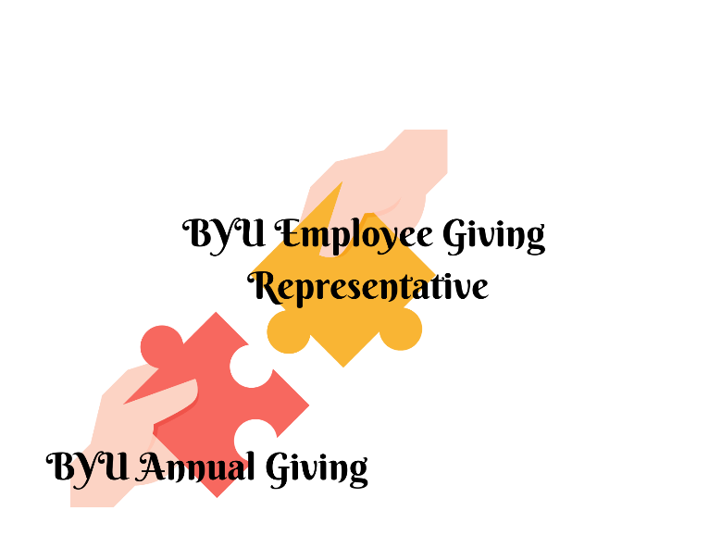BYU Employee Giving Representatives are at the heart of the employee giving campaign. Your efforts to help spread campaign information is vital and appreciated.

**Please:**

* **Educate your area co-workers**
* **Explain the importance of participating**
* **Answer questions**
* **Invite participation**

Together we provide a robust approach to educating, inviting, and expressing appreciation to BYU Employees for their contributions both financial and otherwise which bless the lives of so many, especially students.

If you requested posters and/or employee packets they are included with this packet. All employees will receive the same general information via email.

The campaign runs through the month of March. **If you have any questions, please contact Diana Moon at employeegiving.byu.edu or 801.356.5327**

**BYU Employee Giving Campaign Email Schedule**

*Emails will be sent from the BYU Annual Giving Office*

Feb 23 - Campaign Announcement & Introduction to nominating employees who exemplify Sharing. Lifting. Inspiring.

Mar (TBD) - Two Y News communications (1) campaign announcement (2) nomination invitation

Mar 1 - Invitation to nominate a co-worker who exemplifies Sharing. Lifting. Inspiring.

Mar 7 - Invitation to Give

Mar 9 - Invitation to Give

Mar 14 - Nomination request or Thanks for the nominations depending on response

Mar 23 - Invitation to Give

Mar 28 - Invitation to Give

Apr 13 - Report Back to all employees

**BYU Employee Giving Representative Luncheon April 11th**

Watch for your email invitation in March. We will discuss what went well and opportunities for improvement. I'm excited to hear from you. Please **come prepared to share your ideas** for 2024! Employee Giving Representatives and College Deans / Department Heads are invited to attend. You can also RSVP to [employeegiving@byu.edu](mailto:employeegiving@byu.edu).

**Tips & Presentation Ideas**

* **Be personal**. Make a phone call, drop a note, send an email about the program, etc.
* **Be respectful.** There are many worthy causes to support. Giving back to BYU is optional.
* **Be appreciative**. Thank everyone who participates in the campaign.
* **Be enthusiastic**. Educate and motivate. Remind peers that **every contribution no matter the size, makes a difference.**
* **Be assuring.** Only Philanthropies will know if someone contributes or how much is given.
* **Be informed.**
  + BYU Employee Giving is not part of the United Way Campaign.
  + BYU Employee Giving is not part of the Choose 2 Give Campaign. C2G is a student campaign encouraging students to participate in philanthropy.
  + 100% of funds are used as designated by the donor.

**How can a gift be made:**

|  |  |  |  |
| --- | --- | --- | --- |
| **During the Campaign** | **After the campaign** | **Payroll Deduction** (monthly gift) | **Planned Giving** |
|  |  |  |  | |

***You can also create a Signature Scholarship. Learn more at give.byu.edu/signature***

|  |  |
| --- | --- |
| **Frequently Asked Questions** | |
| Q: | Who is Philanthropies and what is its relationship to BYU Annual Giving / BYU Employee Giving? |
| A: | Philanthropies operates as a department of the Office of the Presiding Bishopric and is responsible to correlate, encourage, and facilitate contributions beyond tithes and offerings to the Church and its affiliate organizations. Funds from the Philanthropies annual operating budget were allocated for the Employee Giving campaign. |
| Q: | What is the Employee Giving Campaign? |
| A: | The Employee Giving Campaign at Brigham Young University offers an opportunity for faculty and staff to help students achieve their educational goals through contributions. Most contributions are made through recurring gifts. One-time donations are also welcome. |
| Q: | When is the campaign? |
| A: | The campaign runs the month of March. Gifts can be made throughout the year. Employees that have been giving for years are invited to increase their gift. |
| Q: | Why give to BYU? |
| A: | **Your Donations Change Lives. By providing resources that create inspiring learning opportunities, you assist BYU in fulfilling its student-focused mission.**Most employees give because they know that students will be blessed by their donations. |
| Q: | What materials do I pass on to my colleagues? |
| A: | It is up to you to determine how to best approach your peers with these materials. |
| Q: | What do I do if I receive gift envelopes? |
| A: | If there are employees who don’t wish to go online, they may use hard copies to give. All gift envelopes are to remain secure and confidential. Sealed envelopes can be mailed or sent via campus mail to Philanthropies / BYU Annual Giving Office, 215D, 1450 N University Ave Provo. |
| Q: | How much should employees give? |
| A: | There is no recommended amount. Regardless of size, every gift makes a difference. |
| Q: | My area would like to establish a department scholarship. Where do I start? |
| A: | Please contact Diana Moon at 801-356-5327 at [employeegiving.byu.edu](mailto:employeegiving@byu.edu) |
| Q: | What if my spouse contributes for both of us through his or her paycheck? |
| A: | That is fantastic! Each employee is counted individually in participation numbers, so they may wish to consider starting their own payroll deduction and adjust the overall gift amount accordingly. |
| Q: | Can I make a recurring gift? |
| A: | Yes! Recurring gifts can be made online at [give.byu.edu/egc23](https://donate-give.churchofjesuschrist.org/BYUEGC23) **DURING** the campaign OR [give.byu.edu/employeegiving](https://donate.churchofjesuschrist.org/donations/byu/employee-giving.html) **AFTER** the campaign, by payroll deduction at <give.byu.edu/payroll>, over the phone by calling (801) 356-5300, or by completing the reply card in the employee packet. |

**Scenarios**

The following list has been compiled as a guide for handling challenges that may arise as you begin to facilitate the Employee Giving program in your area.

**“I recently submitted my United Way (or Choose2Give) card, so I’m already giving. This is basically the same thing, right?**

**Possible response:**

* The United Way is a charitable organization that supports worthy causes in our community. All the money donated goes off campus to support things like women’s shelters and literacy centers. BYU’s support for that campaign is the university’s way of being a good neighbor to our community.
* Money donated through the Employee Giving campaign stays here on campus. It supports scholarships, Dean’s funds, mentoring, etc.
* Choose2Give is a third program which invites students to donate money to scholarship funds for other students. Employees are not asked to donate to Choose2Give.

**Your Dean/Department Chair/Supervisor doesn’t support this program and doesn’t want it to appear that s/he is asking faculty members to contribute, so you won’t be allowed to make a presentation to promote this campaign. What other ways are there to get the word out and rally support?**

**Possible response:**

* Understand the objection(s). If there are any misconceptions, clarity them.
* Ask if you may contact people individually, by email, or in informal gatherings to explain the program.

**You feel as though you gave an inspiring presentation to kick off the campaign, and a few envelopes have come back to you, but it seems like some people are avoiding you and don’t intend to participate. What last effort can you make to positively promote the spirit of sacrifice and the culture of giving?**

**Possible response:**

* Send a reminder toward the end of the campaign asking those who may not have responded yet to review their circumstances and see if they can give a few dollars to help and lift another. Emphasize that any amount will be welcome and appreciated.

**Scenarios**

**“I already donate to BYU by paying my tithing on every single paycheck I receive, and it’s a pretty big donation. How will a few dollars more from me donated through this campaign make any difference?”**

**Possible responses:**

* When one donation is added to thousands of others, the sum and resulting impact grows exponentially. By joining with the other employees, one person giving to BYU can make one incredible difference in the life of one person. This is the power of one.
* BYU enjoys the sponsorship of The Church of Jesus Christ of Latter-day Saints which provides financial support for our campus operations. Unlike other universities, we are not tasked with raising funds for necessities. Instead, every donor-contributed dollar beyond tithing accelerates the work of our campus community through enhanced academic programs, mentoring opportunities, and scholarships that otherwise would not be available. Improvements are purposeful and help BYU become the best it can be.

**“The economy is still uncertain, and I don’t have any extra income. There’s no way I can donate to BYU through Employee Giving.”**

**Possible responses:**

* I know it’s a really hard time right now for a lot of people. The difficult economy makes our donations that much more important and valuable. A few dollars as a one-time gift or monthly donation really adds up when combined with the thousands who donate.
* We are inviting employees to share a little of what they have. Any amount is welcome.

**Sweet Ideas**

You may choose to use treats as an incentive for participating in the campaign. The following are some taglines for popular treats that promote our cause. You are welcome to think of your own.

|  |  |
| --- | --- |
| **Treat** | **Tagline** |
| 100 Grand | Your participation is worth 100 GRAND to us. Thanks for giving! |
| Almond Joy | Your donation will bring great JOY to others. |
| Crunch | You came through in a CRUNCH! Thanks for participating. |
| Donuts | DONUT feel good to help someone in need? |
| Extra | Thanks for going the EXTRA mile. |
| Fast Break | Take a FAST BREAK to fill out your packet. |
| Good & Plenty | You do GOOD & PLENTY around here. Thanks! |
| Gum | Thank you for CHEWsing to give to BYU! |
| Heath | Giving is good for your mental, emotional, and spiritual HEATH! |
| Hershey’s Special Dark | Your donations are SPECIAL! Thanks for participating! |
| Hershey’s Treasures | We hope you know how much we TREASURE you! |
| Kudos | KUDOS to you for participating in Employee Giving! |
| Lifesavers | You're a LIFESAVER when you help someone in need. |
| Look | LOOK at how much your donations help! |
| M & M’s | Thank you for your Marvelous & Mighty help! |
| Mentos | Your donation has MENTOSomuch to us! |
| Milky Way | Your help has been out of this world. |
| Mints | Your donation has MINT so much to us. |
| Now & Later | The donations you make to BYU will help NOW & LATER. |
| Pay Day | PAY DAY is the perfect time to share! |
| Riesen | What's your RIESEN for giving? Share your story at <employeegiving@byu.edu> |
| Rocky Road | Thanks for giving--even when you're traveling on a ROCKY ROAD! |
| Skor | Help us SKOR big by helping others. |
| Smarties | It's SMARTIES like you that help make BYU so great! |
| Snickers | Nobody's SNICKERing about the good job you did. Thanks for helping! |
| Spree | Go on a different kind of SPREE. Give to those in need. |
| Swedish Fish | There's nothing FISHY about it. Your donation will do a lot of good. |
| Symphony | We would like to thank you in a SYMPHONY of voices. |
| Take 5 | It will only TAKE 5 minutes to make an Employee Giving donation. |